Experiment 13: Design Turing Machine (TM) Using Simulator to Accept the Language
Aim
To design and simulate a Turing Machine (TM) that accepts the language
where the number of b's is twice the number of a's.

Algorithm
- Start from the leftmost symbol of the input string.
- Replace the first unmarked a with X.
- Move right and replace the first two unmarked b's with Y.
- Return to the beginning of the tape.
- Repeat Steps 2–4 until all a's are marked.
- Check whether any unmarked b remains.
- If all a's are matched with exactly two b's each and no extra symbols remain, accept the string.
- Otherwise, reject the string.

Procedure
- Open the Turing Machine simulator (e.g., JFLAP).
- Create the required states.
- Mark the initial state as the start state.
- Add transitions to mark each a as X.
- For every marked a, mark two corresponding b's as Y.
- Move the tape head back to the beginning after processing each a.
- Repeat until all a's are marked.
- If the tape contains only X, Y, and blank symbols after the input is completely processed, move to the accept state.
- Test the machine with valid and invalid input strings.

Input
abb
aabbbb
aaabbbbbb

Output
Input : abb → Accepted
Input : aabbbb → Accepted
Input : aaabbbbbb → Accepted
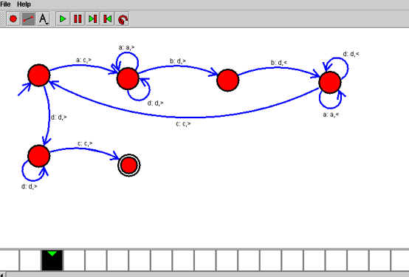

Result
Thus, the Turing Machine (TM) was successfully designed and simulated to accept the language L = { aⁿb²ⁿ | n ≥ 1 }. The machine correctly accepted strings in which the number of b's is exactly twice the number of a's and rejected all other strings.

